First of all, when data is NOT stored in the inventory (file), following is displayed when choosing option 2: 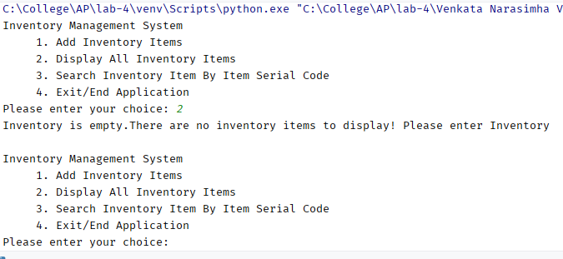

If user chooses option 3 (search an item by Item code), and there are no items in the inventory, following is displayed:

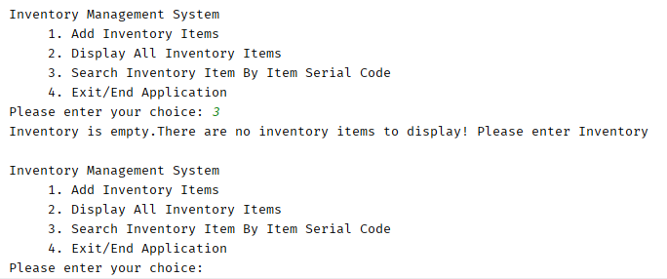

If user enters invalid option, numeric value or non-numeric character, following is displayed:

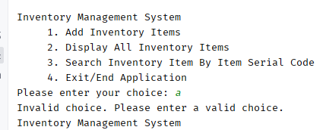

When user chooses option 1 to add an item, following is displayed:

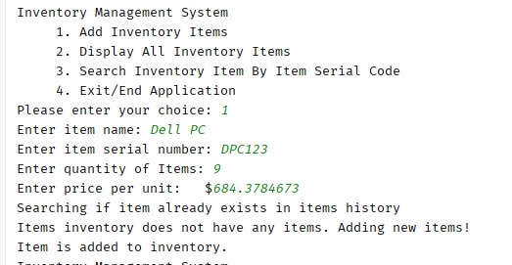

Add another item in the inventory (using option 1)

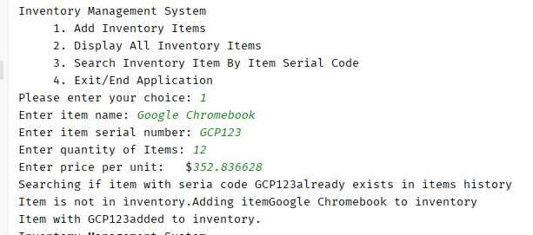

Option/Choice 2 displays all the items in inventory:

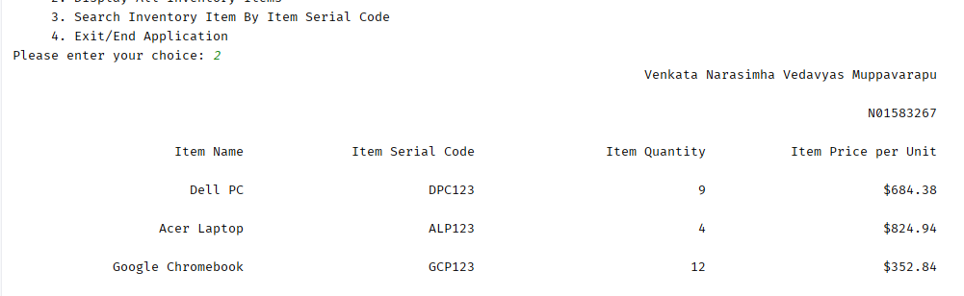

Add another item – that already exists (ALP123 already exists):

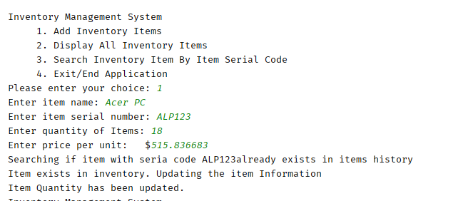

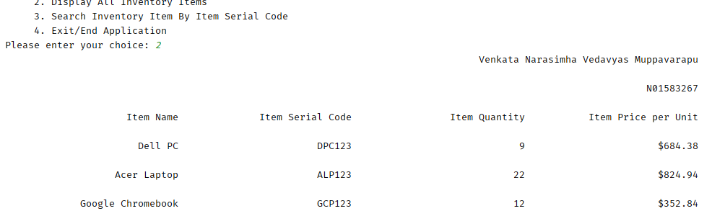

Now adding another item to the inventory, ALP123. Now quantity is also updated as well as price is also increased.

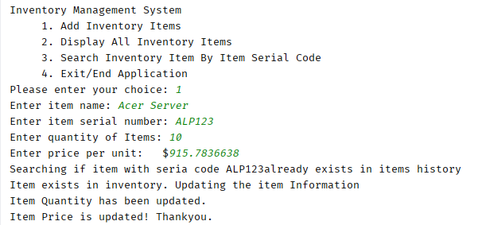

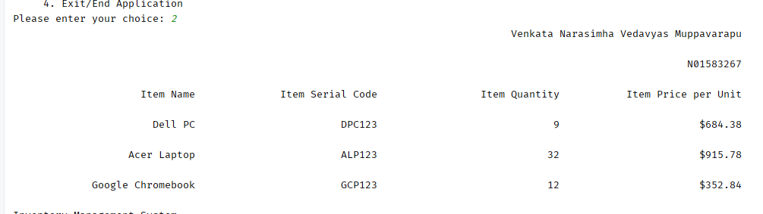

Choosing option 3 to search an item, and item does not exist:

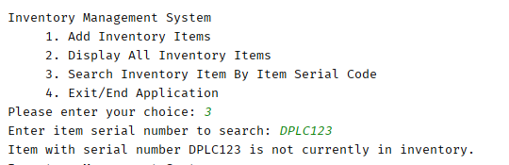

Now choose option 3, when item already exists.

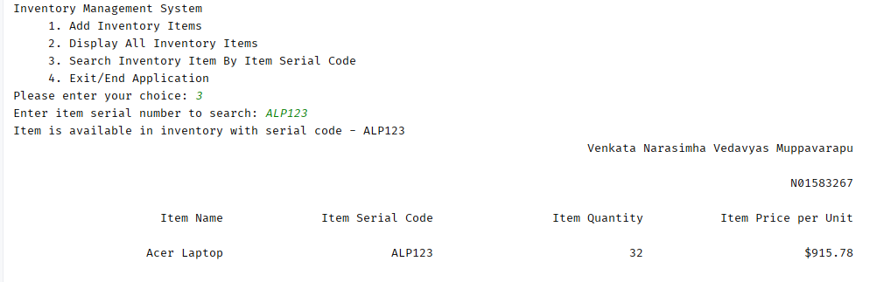

Option 4 ends the application:

